**Hot Food £14.95 per head - Menu 1**

**Choice of 3**

Freshly cooked Chicken Korma, cooked with traditional spices, (medium strength) Served with Basmati Rice and Naan Bread and chips

Freshly cooked Beef Bourguignon - Top Rump braised in red wine, served with Basmati Rice and chips

Freshly cooked Beef Chilli (medium strength), served with Basmati Rice and chips

Lamb Hotpot served with new potatoes and vegetables

Coq au vin served with new potatoes and vegetables

Braised Steak in Red Wine served with new potatoes and vegetables

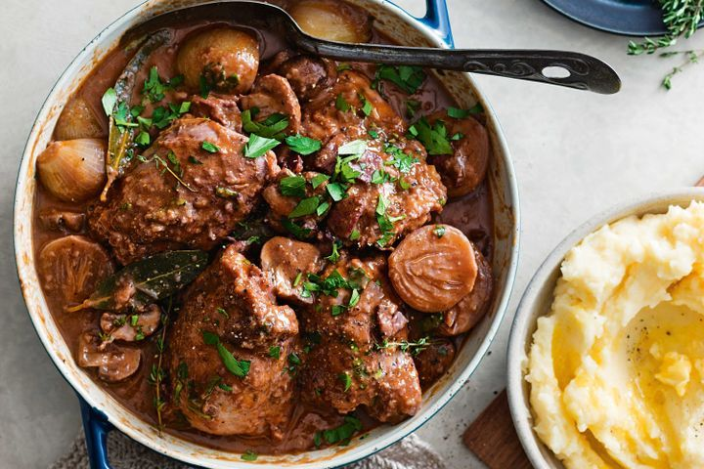

**Cold Buffett £12.95 per head  - Menu 1**

Open sandwiches:

Freshly prepared on Sour dough Bread

King Prawn in Marie Rose sauce displayed on Little Gem lettuce

Freshly Cooked Sirloin of Beef, served with a dash of Horseradish on a bed of Rocket

Smoked Salmon and Cucumber with Cream Cheese

Freshly cooked Ham and Turkey with Mayonnaise on mixed leaves

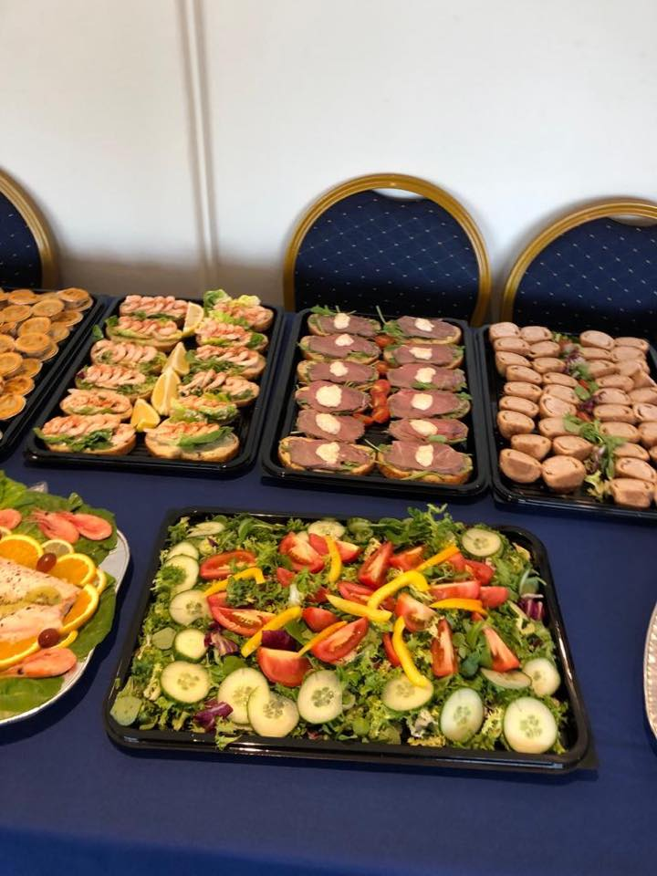Seafood Platter

Home cooked Chicken liver pate served on Crostini’s

Freshly prepared Potato salad

Traditional salad

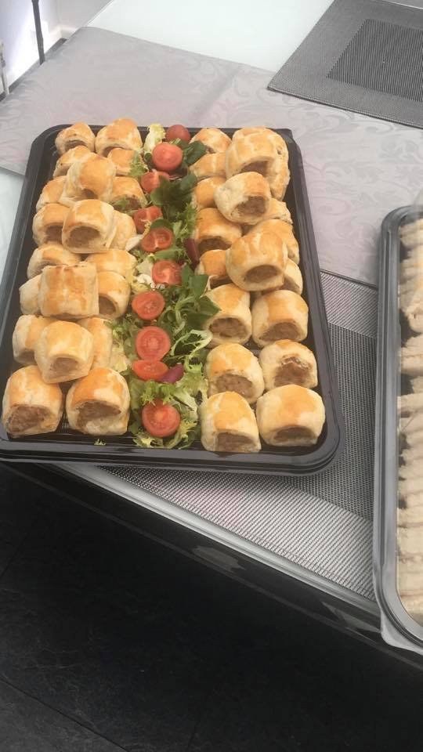Pasta Salad

Freshly baked quiche

Pork pies

Freshly baked Sausage Rolls

**Cold buffet £13.95 per head – Menu 2**

Open sandwiches

Freshly prepared on Sourdough Bread

King Prawn in Marie Rose sauce displayed on Little Gem Lettuce

Freshly Cooked Topside of Beef, served with a dash of Horseradish on a bed of Rocket

Smoked Salmon and Cucumber with Cream Cheese

Freshly Cooked Ham & Turkey mixed with mayonnaise on mixed leaves

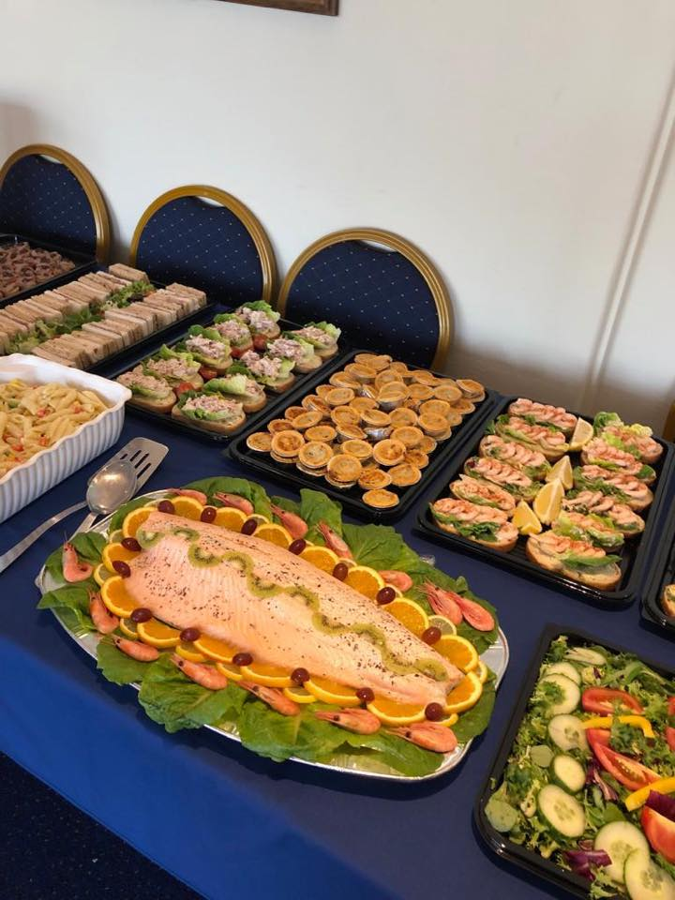

**Poached Salmon Platter**

**Finger Sandwiches:**

Fresh White and Brown Bread

Freshly prepared Egg Mayonnaise

Freshly prepared Tuna Mayonnaise

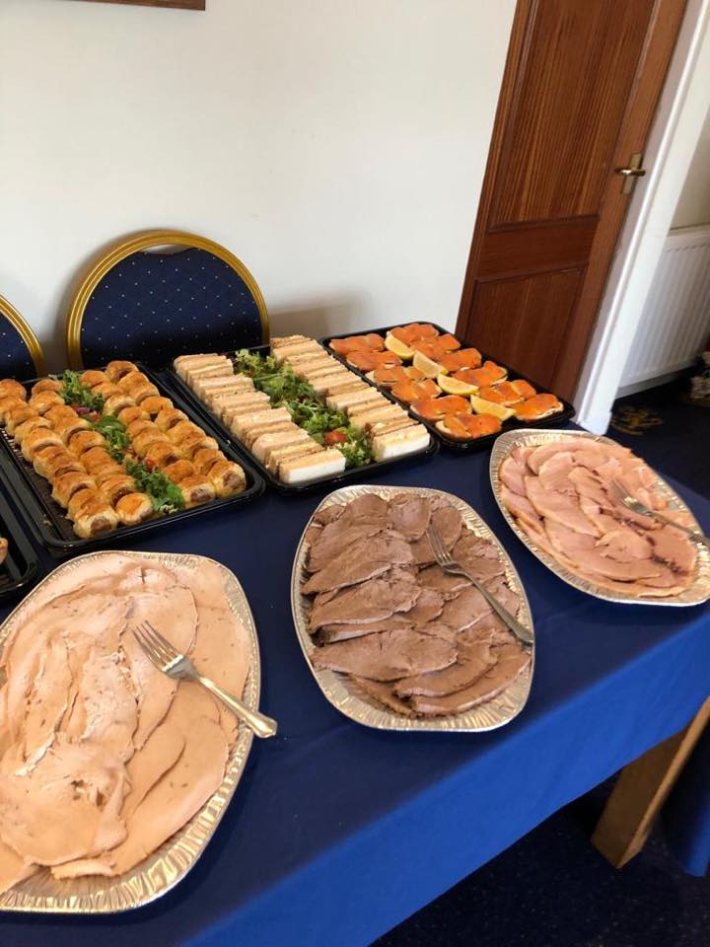Cheddar Cheese (Medium)

Home cooked Honey Roast Ham

Sliced home cooked meats

Turkey Crown/ Sirloin Roast Beef / Honey Roast Ham

Freshly prepared Potato salad

Traditional salad

Pasta Salad

Freshly baked quiche

Pork pies

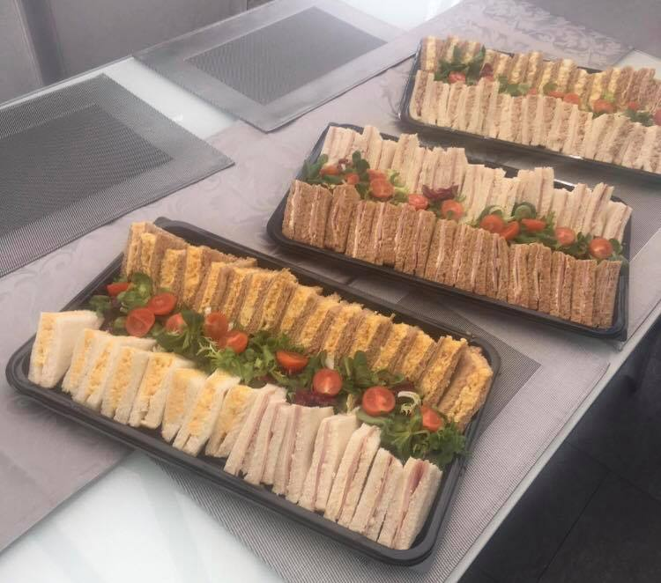Freshly baked Sausage Rolls

Homemade Chicken Liver Pate served on Crostini’s

**Desserts £4.50 per head**

Cheese Cake

Chocolate Fudge Cake

Strawberries and Cream