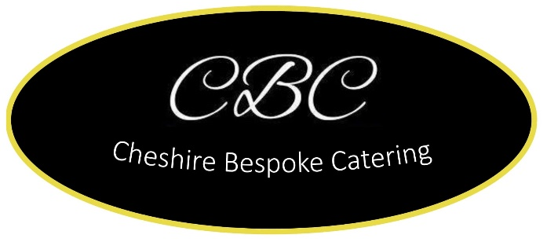

**Homemade Tray bakes**

Sausage Casserole

Cottage Pie

Shepherd’s Pie

Lamb Hot Pot

Lasagne

Beef Chilli

Beef Ragu

Chicken Stroganoff

Meatballs with Tomato sauce

Chicken Korma

Lamb Rogan Josh

Beef Madras

**Homemade Pies**

Minced Beef & Onion Pie

Meat & Potato Pie

Cheese & Onion Pie

Chicken Mushroom Pie

**£13.50 per 4 people**

**£9.50 per 2 people**

**Vegetable Tray Bakes**

Vegetable Lasagne

Vegetable Chilli

Vegetable Moussaka

Mushroom Stroganoff

**£13.50 per 4 people**

**£9.50 per 2 people**

**Sides**

Mash Potato £3.50 per pot

Cauliflower Cheese £5.00 per pot

Roasted Root vegetables per tray

Homemade Pate £7.50

**Tray Bake Puddings**

Chocolate Brownies

Apple Crumble

Flap Jack

Lemon Drizzle

Other

Victoria Sponge Cake

£13.50

We also provide platters of sandwiches and sausage rolls and outside catering and BBQ’s

Any special requests, please let us know.

**Phone Alan on @ 07787566076**

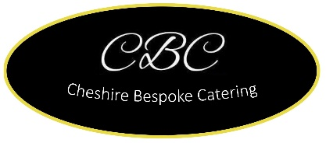**Facebook: Cheshire Bespoke Caterers**